**Hands on 1**

**Create a Spring Web Project using Maven**   
  
Follow steps below to create a project: 

1. Go to <https://start.spring.io/>
2. Change Group as “com.cognizant”
3. Change Artifact Id as “spring-learn”
4. Select Spring Boot DevTools and Spring Web
5. Create and download the project as zip
6. Extract the zip in root folder to Eclipse Workspace

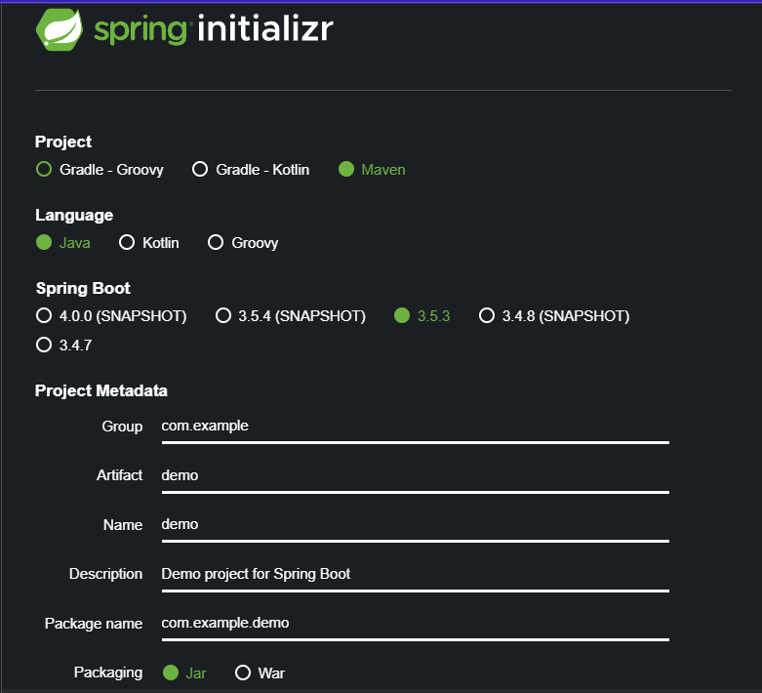

1. Build the project using ‘mvn clean package -Dhttp.proxyHost=proxy.cognizant.com -Dhttp.proxyPort=6050 -Dhttps.proxyHost=proxy.cognizant.com -Dhttps.proxyPort=6050 -Dhttp.proxyUser=123456’ command in command line

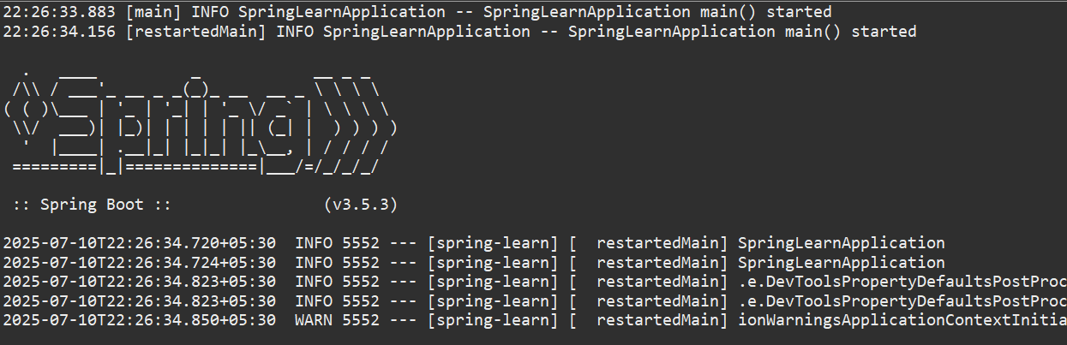

1. Import the project in Eclipse "File > Import > Maven > Existing Maven Projects > Click Browse and select extracted folder > Finish"
2. Include logs to verify if main() method of SpringLearnApplication.

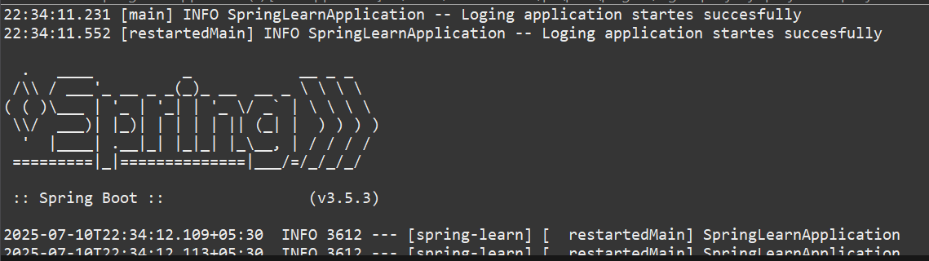

1. Run the SpringLearnApplication class.